Each weapon listed below requires proficiency in it and 14+ agility

KATANA – 1d8, Versatile (1d10)

SHURIKEN - naruto shit 1d4 dmg, creature hit by it has disadvantage on attack in the next round

BO - basically a staff but scales with agility 1d8 bludgeoning, two-handed

NAGINATA - halberd alike weapon 1d10 scales with agility, reach, two-handed

Ōdachi - long katana, 1d12 scales with agility, two-handed

Dsitte – short dagger with 2 blades 1d4 + creature hit by it is incapacitated (if fails constitution save throw against your agility)

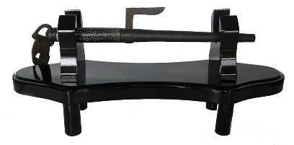

FIREARMS

Rifle – 4d10 piercing, range(300ft) , reload, ammunition (rifle ammo), pierces through resistance, critical 18, reveal, REQUIRES PROFFICIENCY otherwise -10 to hit die.

Pistol – 4d6 piercing, range(60ft), reload, ammunition (pistol ammo), pierces through resistance, reveal, REQUIRES PROFFICIENCY otherwise -10 to hit die.

Sniper rifle – 50 dmg (no modifiers like sneak attack, weapon buff etc. can be applied, IF THE DESCRIPTION OF MODIFIER DOES NOT SPECIFICALLY SAY SO), range(600ft), critical 16, long reload, ammunition, pierces through resistance, long preparation, REQUIRES PROFFICIENCY otherwise can’t hit.

Shotgun – fires in a 20ft cone 5/3/2/1d10 in 5/10/15/20 ft range respectively, reveal, ammunition (shotgun ammo), reload, recoil if character has no profficiency

Light grenade – 50ft range, 30ft aoe, blinds everyone looking in the direction of the target location for 2 rounds

Hand grenade – 50 ft range, 20ft aoe, 6d6 explosion dmg

Pocket pistol – 5d6 piercing (no modifiers like sneak attack, weapon buff etc. can be applied, IF THE DESCRIPTION OF MODIFIER DOES NOT SPECIFICALLY SAY SO), range(30ft), hidden, long reload, ammunition (pocket pistol ammo), always hits and crits in 5ft range, pierces through immunity and resistance, silenced, REQUIRES PROFFICIENCY otherwise -10 to hit die

Weapon properties:

1. Reveal – location of shooter is revealed if he was hiding (unless silencer is used)
2. Long reload – requires 1 action and bonus action to reload (cannot be reloaded by reaction)
3. Critical X – X or higher on hit die are also considered a critical
4. Long preparation – weapon requires 30 seconds to deploy and ready, if weapon is moved it requires another 18 seconds to deploy
5. Silenced – allows user to remain hidden